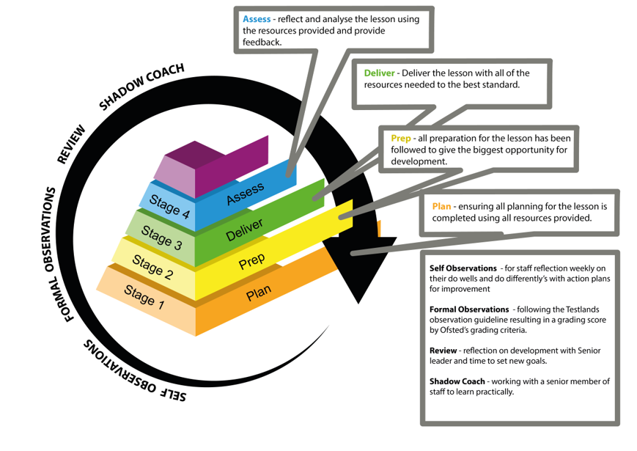
Assess-reflect and analyse the lesson using the resources provided and provide feedback.
Deliver - Deliver the lesson with all of the resources needed to the best standard.
DOW COACH
SHADOW
REVIEW
Prep - all preparation for the lesson has been followed to give the biggest opportunity for development.
IONS
Stage 4
Assess
Plan - ensuring all planning for the lesson is completed using all resources provided.
OBSERVATIONS
Stage 3
Deliver
Stage 2
Prep
Self Observations - for staff reflection weekly on their do wells and do differently's with action plans for improvement
Stage 1
Plan
FORMAL
Formal Observations - following the Testlands observation guideline resulting in a grading score by Ofsted's grading criteria.
ONS
Review - reflection on development with Senior leader and time to set new goals.
4183580 735
Shadow Coach - working with a senior member of staff to learn practically.

